Industrial-NIR-Chemometric-Calibration-Uncertainty-Platform

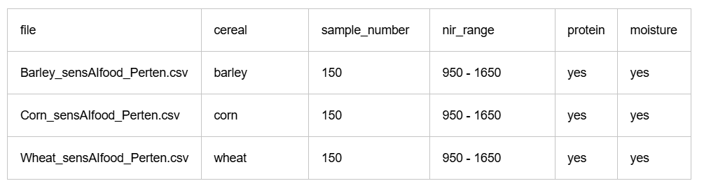
Dataset questions

- How many samples?
150+150+150 = 450 samples

- How many wavelengths?
141 wavelengths

- What wavelength range?
950-1650 nm

- What are the target columns?
Moisture, Protein

- Are there missing values?

- What grain types exist?
Barley, Corn, Wheat

- What varieties exist?
Barley – Unknown
Corn – Unknown
Wheat – Durum, Canadian Hard R, Wheat

- What instruments (spectrometer) exist?
Barley - Perten_DA7200, Perten_DA72xx, Perten_DA7440
Corn – Perten_DA7200, Perten_DA7250
Wheat – Perten_DA7200, Perten_DA7250, Perten_DA7300

- What countries exist?
Barley - Croatia, Denmark, Slovenia, Sweden, US
Corn - Croatia, South Africa, Turkey, US
Wheat – Australia, Canada, Norway, Sweden, Spain, UK, US

- What years exist?
Barley - 2004,2006,2009,2011,2016
Corn – 2006, 2007, 2011, 2012, 2017
Wheat – 2002, 2006, 2007, 2008, 2011, 2014

- Are there duplicate samples?
No.

- What exactly do the spectral values represent — reflectance, absorbance, log(1/R), etc.?

